**A**

**PROJECT REPORT**

**ON**

**“CUSTOMER SATISFACTION TOWARDS NIKE FOOTWEAR”**

**IN THE PARTIAL FULFILLMENT OF THE REQUIREMENT FOR THE AWARD OF THE DEGREE OF**

**SUBMITTED TO H.P.UNIVERSITY, SHIMLA (H.P.)**

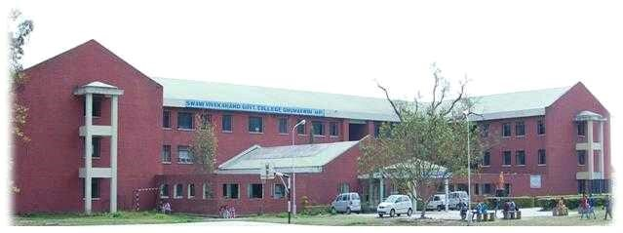

**BACHELOR OF BUSINESS ADMINISTRATION**

**SESSION 2021-2022**

**IN SWAMI VIVEKANANDA GOVT.COLLEGE ,GHUMARWIN**

**SUPERVISIOR BY: SUBMITTED TO:**

Ms. Rajni Thakur ANKUSH KUMAR

Asst. Prof. (BBA) BBA 6TH SEM

ROLL NO: 5190350007

# ACKNOWLEDGEMENT

“Acknowledgement is an art; one can write glib stanzas without A word on the hand one can make a simple expression of Gratitude” I take the opportunity to express my gratitude to all of them who in same or other way helped me to accomplish this challenging project report in **Customer Satisfaction towards Nike Footwear**. No amount of written expression is sufficient to show my deepest sense of gratitude to them. I very sincerely acknowledge my sense of reference to **Prof. Ram Krishan (Principal), Assistant Professor Rajender Kumar (Coordinator BBA), and Assistant Prof. Rajni Thakur** and faculty members of **Swami Vivekananda Govt. College Ghumarwin.** I also express deepest gratitude to my family for their blessing and good wishes.

.

**Ankush Kumar**

# DECLARATION

I hereby declare that the project report was submitted by me under the supervision and Guidance of **Ms. Rajni Thakur,** Project Guide of **SwamiVivekananda Govt.College, Ghumarwin** in partial fulfillment for the Award of The Degree of **Bachelor of Business Administration(BBA)** I further declare that I am solely responsible for omission and commission of error if any.

The information and data given in the report is authentic to the best of my knowledge.

**Date:**

**Signature:**

# CERTIFICATE

This is to certify that the project Report entitled **“Project Report on Customer Satisfaction towards Nike footwear”** for the award of the degree of Bachelor of Business Administration (BBA) from Himachal Pradesh University, is a record of Project Report carried out of **ANKUSH KUMAR of BBA 6TH Semester Swami Vivekananda Govt. College Ghumarwin University Roll No. 5190350007**under my supervision and guidance no part of this report has been submitted to any other Degree/ Diploma and this report may be taken for evaluation.

**Signature of Guide Signature of Student**

**Signature of Coordinator**

# PREFACE

This project report on **Customer Satisfaction towards Nike Footwear** has been conducted to observe the preferences of customer. This system of education is highly appreciated as it provides the students with an opportunity to acquaint them with the outside world. The practical work helps the students to view the real business world closely, which in turn widely influences their conception and perception.

In this project 50 respondents are selecting for knowing their perception regarding Nike footwear. For this purpose information is collected from some areas of Bilaspur district.

# TABLE OF CONTENTS

|  |  |  |  |
| --- | --- | --- | --- |
| **S.NO.** | **CHAPTER** | **CONTENTS** | **PAGE.NO.** |
| **1.** | **CHAPTER-1** | **INTRODUCTION TO THE**  **COMPANY:-**  History Of The Company  Introduction To The Nike Footwear Product:  1.1) Recent Development  1.2) Future Plan  1.3) 4PS Of Nike  1.4) SWOT Analysis | **8 - 20** |
| **2.** | **CHAPTER-2** | **INTRODUCTION TO THE TOPIC:-** CUSTOMER SATISFACTIN:  2.1) Importance, Features & Advantage  2.2) Objective Of The Study  2.3) Scope Of The Study  2.4) Importance Of The Study  2.5) Research Project Aims  2.6) Limitations Of The Study | **21 - 28** |
| **3.** | **CHAPTER-3** | **RESEARCH METHODOLOGY:-**  3.1) Objective Of The Study   1. 2)Need of the study    1. Scope Of The Study    2. Research Design    3. Sample Size    4. Limitations Of Research | **29 - 34** |
| **4.** | **CHAPTER-4** | **DATA ANALYSIS &**  **INTERPRETATION** | **35 - 50** |
|  |  | **FINDING& SUGGESTION** | **52 -56** |
|  |  | **CONCLUSION** | **57 - 58** |
|  |  | **BIBLIOGRAPHY** | **59** |
|  |  | **QUESTIONNAIRE** | **60** |

## EXECUTIVE SUMMARY

This marketing research project report has been written keeping in mind the Indian operations of Nike Inc. – the global sports shoe giant. It aims first, at analyzing the sports shoe industry of India and finding a place in it for Nike. It then sets out to describe the target audience for the product range and finally suggests a host of marketing strategies and activities that will help Nike to achieve its target of becoming the #1 sports shoe brand in India.

The project report begins with a brief overview of the product category being dealt with, namely premium quality sports shoes. It also dwells briefly on the history of the company and its current position and activities.

The project moves on to the crux of the matter – the marketing plan to be followed by Nike in India. Firstly, the objectives behind this plan and the core strategy are stated. Customers to be eventually targeted are described and compared with competitors‟ customer targets. After stating the objectives and reasoning behind them, the actual marketing programs are described in detail. This includes aspects such as pricing, advertising, promotion, sales, channels, and the company web site. Suggestions are made on each and every one of these aspects; improvements and innovations are recommended. Once implemented, can be monitored and controlled.

# CHAPTER-1

**Introduction**

**Introduction : Nike** is an American multinational corporation that is engaged in the design, development, manufacturing, and worldwide marketing and sales of footwear, apparel, equipment, accessories, and services. The company is headquartered near Beaverton, Oregon, in the Portland metropolitan area. It is the world's largest supplier of athletic shoes and apparel and a major manufacturer of sports equipment, with revenue in excess of US$24.1 billion in its fiscal year 2012 (ending May 31, 2012). As of 2012, it employed more than 44,000 people worldwide. In 2014 the brand alone was valued at $19 billion, making it the most valuable brand among sports businesses. As of 2017, the Nike brand is valued at $29.6 billion.

The company was founded on January 25, 1964, as **Blue Ribbon Sports**, by Bill Bower man and Phil Knight, and officially became Nike, Inc. on May 30, 1971. The company takes its name from Nike, the Greek goddess of victory. Nike markets its products under its own brand, as well as Nike Golf, Nike Pro, Nike+, Air Jordan, Nike Blazers, Air Force, Nike Dunk, Air Max, Composite, Nike Skateboarding, and subsidiaries including Brand Jordan, Hurley International and Converse. Nike also owned Bauer Hockey from 1995 and 2008, and previously owned Cole Han and Umbra.

In addition to manufacturing sportswear and equipment, the company operates retail stores under the Nike town name. Nike sponsors many high-profile athletes and sports teams around the world, with the highly recognized trademarks of "Just do it" and the Swoosh logo.

**INTRODUCTION TO THE NIKE FOOTWEAR**

**PRODUCT:-**

**Nike India Ltd.** is India’s largest footwear company. Nike first established itself in India in 1931 and commenced manufacturing shoes in Bhavnagar in 1936. The company has its Headquarters in Kolkata and manufactures over 33 million pairs per year in five plants located in Bhavnagar (West Bengal), Faridabad (Haryana), Bangalore

(Karnataka), Patna (Bihar), Hosur (Tamil Nadu). It secures its leather supply from two tanneries in Mokamehghat (Bihar) and Bhatnagar (West Bengal). It has a distribution network of over 1,500 retail stores and 27 wholesale depots provide excellent access to consumers and wholesale customers throughout India.

## 1.1) RECENT DEVELOPMENTS:-

Nike India has said that it’s Faridabad and Mokamehghat units are being taken over by Fashion Shoe Private Ltd and BDCL Enterprises Pvt Ltd, respectively. The company is also enabling the buyback provision in its Articles of association to enable buy back of shares.

The assets and liabilities of both the units will be transferred to these companies and shares will be offered in the agreed ratio to the existing shareholders of Nike India Ltd on a record date, which will be fixed by the Calcutta High Court.

While retail sales have increased both in value and volume, wholesale sales have declined due to restriction of supplies as a means to Recover customers outstanding. General recession and sluggish market conditions in the industry also have had a direct impact on lower sales and profitability. Resistance of consumers to price rises in popular volume products as well as discounts to clear slow-moving stocks and underutilization of production capacity adversely affected the operational results. The lockout declared at the Peenya factory on October 1, 2007 due to serious industrial relation problems and noncompliance with the tripartite settlement has been withdrawn. The footwear manufactured in this factory, which was shifted to the company’s other factories and associated manufacturers, will now be gradually produced within the factory. The commencement of production from this factory will help in re-cooping the minimal loss being suffered by the company from this lockout.

## 1.2) FUTURE PLAN:-

The management says that it is not averse to outsourcing if it worked out cheaper. It is also open to the idea of importing shoes - mostly from China - if it works out cheaper. Nike and Reebok India Company have announced an agreement to foray into retailing partnership for sale of Reebok and Rockport footwear in Nike outlets. The partnership entails retailing a range of sports shoes for walking, running, tennis and training for personal fitness and sports ranging between Rs 900-2,500.

An attractive valuation compared to its peers is the main trigger for the scrip. Besides, the company’s aggressive focus on retailing and revamping of business (a division into shoes and apparels) is also helping sentiment for the scrip. Plans are afoot to start selling apparel in India made by the joint venture North Star. There’s talk that the company is planning on a voluntary retirement scheme (VRS) to cut costs.

Despite reducing its losses for the last quarter, Nike India has, over the last few quarters, been continuously recording weak performances as a result of an overall slowdown in the industry due to lower consumer spending. Increasing domestic competition, particularly from the unorganized sector, has also been eroding into the company’s market share.

The company is finding it difficult to maintain its market share in a highly price-sensitive Indian market, despite having strong brand recall. 97% of the company’s revenues are from the domestic market while the remainder is from exports. Nike India is the biggest player in the Indian shoe market.

Nike India’s major problems include its high cost of production and low emphasis on marketing. The company may be able to address the first problem through outsourcing products. Bata’s brand image has been restricted to that of a company that emphasizes on utilitarian products more than trendy ones. Customers feel the company is lacking in innovation. Hence, their preference has shifted to other local brands.

Nike India has a large marketing network with over 1,500 showrooms, 27 wholesale depots and eight retail distribution centers across the country.

Besides, there is a network of 350 exclusive wholesalers servicing 25,000 dealers all over the country. However, in spite of this and the license to sell other brands like Nike, Hush Puppies and Lotto, Nike has not been able to improve sales consistently. In 2008, it also entered into a retailing tie-up for Lee Cooper shoes.

Nike India has also been trying to focus on aggressive marketing of its product. The company has been going through a period of transition for the past one year. With the expansion of the retail industry in New Delhi and Mumbai, the company has recently decided to shift its marketing operations to Delhi in order to provide value shopping for its customers. However, the manufacturing activity and the registered office will continue at Kolkata.

Nike India has plans to invest in sophisticated machinery to retain its niche place in manufacturing. The company has put a fresh focus to its retail business. The company has decided to cleanse its wholesale operation by building relationships with credit-worthy buyers. It is to the company’s credit that it has lately overhauled its marketing set-up into a four-tier retail structure that will be stocked with products matching the area’s customer profile. A Nike outlet in an up market place will offer a distinctly different range of footwear from another in the suburbs.

Nike India has also been trying to focus on aggressive marketing of its product. The company has been going through a period of transition for the past one year. With the expansion of the retail industry in New Delhi and Mumbai, the company has recently decided to shift its marketing operations to Delhi in order to provide value shopping for its customers. However, the manufacturing activity and the registered office will continue at Kolkata.

Nike India has plans to invest in sophisticated machinery to retain its niche place in manufacturing. The company has put a fresh focus to its retail business. The company has decided to cleanse its wholesale operation by building relationships with credit-worthy buyers.

It is to the company’s credit that it has lately overhauled its marketing set-up into a four-tier retail structure that will be stocked with products matching the area’s customer profile. A Nike outlet in an up market place will offer a distinctly different range of footwear from another in the suburbs.

At the same time, with the opening up of the economy, more and more goods will be imported from China. This may significantly affect Nike India’s prospects unless it manages to wean away customers with a drastic cut in costs. Alternatively, like other Indian manufacturers, even Nike may consider relocating its manufacturing bases in China. However, it is not that easy a task to undertake.

The footwear industry in India is highly fragmented and dominated by the unorganized sector. The industry size is around Rs 75 Billion and is growing at around 10% annually. It competes with Indian players such as Liberty Shoes, Phoenix International, Mirza Tanners, Tata’s, Action Shoes and Lakhani Shoes and global players like Adidas, Reebok and Nike. Accessories and garments contribute footwear sales account for more than 96% of sales while the balance.

## 1.3) 4P’S OF NIKE:-

Nike’s 4Ps comprised of the following approaches to pricing, distribution, advertising and promotion, and customer service:

### 1. Pricing:-

Nike’s pricing is designed to be competitive to the other fashion shoe retailers. The pricing is based on the basis of premium segment as target customers. Nike as a brand commands high premium.

### 2. Place:-

Nike shoes are distributed to Multi Brand store front and the exclusive Nike stores across countries. While this necessitates a second trip for the customer to come and pick up the shoes, it allows Nike to offer a much wider selection than any of the competition.

### 3. Promotion:-

Location, targeted advertising in the newspaper and strategic alliances serves as the foundation of Nike advertising and promotion effort. The athletes and other famous sports personalities are always taken as brand ambassadors. They form the prime building blocks of their portion strategy.

### 4. Product:-

The product range of Nike comprise of shoes, sportswear, watches etc. Its product history began with long distance running shoes in 1963. (Past 17 years: Air Jordan basketball shoes). Wide range of shoes, apparel and equipment.

## 1.4) SWOT ANALYSIS:-

### Strengths:-

Nike is a very competitive organization. Phil Knight (Founder and CEO) is often quoted as saying that 'Business is war without bullets.' Nike has a healthy dislike of its competitors. At the Atlanta Olympics,

Reebok went to the expense of sponsoring the games. Nike did not.

However Nike sponsored the top athletes and gained valuable cowage.

Nike has no factories. It does not tie up cash in buildings and manufacturing workers. This makes a very lean organization. Nike is strong at research and development, as is evidenced by its evolving and innovative product range. They then manufacture wherever they can produce high quality product at the lowest possible price. If prices rise, and products can be made more cheaply elsewhere (to the same or better specification), Nike will move production. Nike is a global brand. It is the number one sports brand in the World. Its famous 'Swoosh' is instantly recognizable, and Phil Knight even has it tattooed on his ankle.

### 2. Weaknesses:-

The organization does have a diversified range of sports products. However, the income of the business is still heavily dependent upon its share of the footwear market. This may leave it vulnerable if for any reason its market share erodes.

The retail sector is very price sensitive. Nike does have its own retailer in Nike Town. However, most of its income is derived from selling into retailers. Retailers tend to offer a very similar experience to the consumer. Can you tell one sports retailer from another? So margins tend to get squeezed as retailers try to pass some of the low price competition pressure onto Nike.

### 3. Opportunities:-

Product development offers Nike many opportunities. The brand is fiercely defended by its owners whom truly believe that Nike is not a fashion brand. However, like it or not, consumers that wear Nike product do not always buy it to participate in sport. Some would argue that in youth culture especially, Nike is a fashion brand. This creates its own opportunities, since product could become unfashionable before it wears out i.e. consumers need to replace shoes.

There is also the opportunity to develop products such as sport wear, sunglasses and jewelry. Such high value items do tend to have associated with them, high profits.

 The business could also be developed internationally, building upon its strong global brand recognition. There are many markets that have the disposable income to spend on high value sports goods. For example, emerging markets such as China and India have a new richer generation of consumers. There are also global marketing events that can be utilized to support the brand such as the World Cup (soccer) and The Olympics.

### 4. Threats:-

Nike is exposed to the international nature of trade. It buys and sells in different currencies and so costs and margins are not stable over long periods of time. Such an exposure could mean that Nike may be manufacturing and/or selling at a loss. This is an issue that faces all global brands.

The market for sports shoes and garments is very competitive. The model developed by Phil Knight in his Stamford Business School days (high value branded product manufactured at a low cost) is now commonly used and to an extent is no longer a basis for sustainable competitive advantage. Competitors are developing alternative brands to take away Nike's market share.

As discussed above in weaknesses, the retail sector is becoming price competitive. This ultimately means that consumers are shopping around for a better deal. So if one store charges a price for a pair of sports shoes, the consumer could go to the store along the street to compare prices for the exactly the same item, and buy the cheaper of the two. Such consumer price sensitivity is a potential external threat to Nike.

**NIKE SIGNATURE:-**

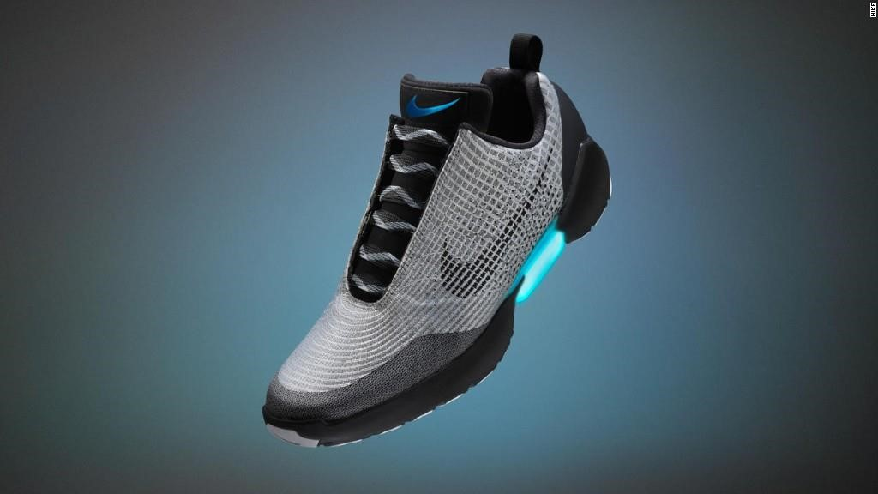

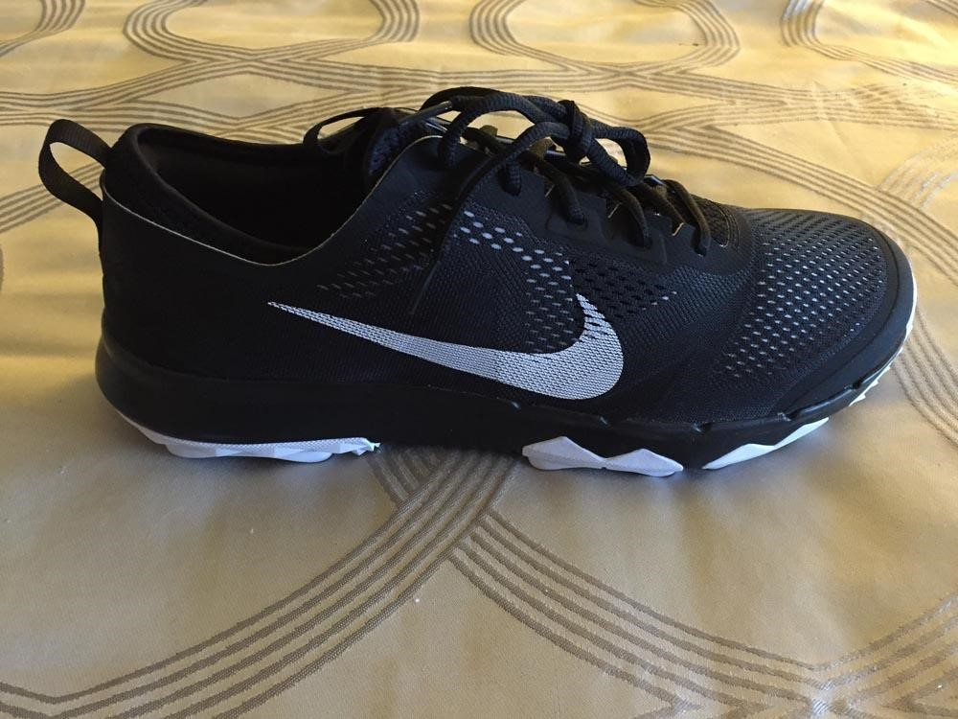

# CHAPTER-2

## PREFERENCE

Businesses monitor customer satisfaction in order to determine how to increase their customer base, customer loyalty, revenue, profits, market share and survival. Although greater profit is the primary driver, exemplary businesses focus on the customer and his/her experience with the organization. They work to make their customers happy and see customer satisfaction as the key to survival and profit. Customer satisfaction in turn hinges on the quality and effects of their experiences

**What exactly Customer Satisfaction is?**

The definition of customer satisfaction has been widely debated as organizations increasingly attempt to measure it. Customer satisfaction can be experienced in a variety of situations and connected to both goods and services. It is a highly personal assessment that is greatly affected by customer expectations. Satisfaction also is based on the customer’s experience of both contact with the organization (the “moment of truth” as it is called in business literature) and personal outcomes. Some researchers define a satisfied customer within the private sector as “one who receives significant added value” to his/her bottom line—a definition that may apply just as well to public services. Customer satisfaction differs depending on the situation and the product or service. A customer may be satisfied with a product or service, an experience, a purchase decision, a salesperson, store, service provider, or an attribute or any of these. Some researchers completely avoid “satisfaction” as a measurement objective because it is “too fuzzy an idea to serve as a meaningful benchmark.” Instead, they focus on the customer’s entire experience with an organization or service contact and the detailed assessment of that experience.

### 2.1) IMPORTANCE, FEATURES &ADVANTAGES:-

Customer satisfaction with a purchase depends on how well the product’s performance lives up to the customers’ expectations. Customer satisfaction is a key influence on future buying behavior. Satisfied customers buy again and tell others about their good experiences dies-satisfied customers of ten switches to competitors and disparage the products to others.

**For example:**

 Service Promptness

 Courtesy of Staff

 Responsiveness

 Understanding the customer problem etc.

The findings of the company performance should be analyzed both with all customers and by key segments of the customer population. The essential starting point for Customer Satisfaction Measurement (CMS) is exploratory research. Since satisfaction is about an organization’s ability. To meet customer requirement one has to start by clarifying with customers exactly what those requirements are. This is done through exploratory research using focus groups or one to one depth interviews.

Two main factors determine the accuracy of CMS. The first is the asking the right question and the second is the asking them to the right people sample of customers which accurately reflects the customer base.

Customer satisfaction depends on the product’s performance relative to a buyer’s expectation, the customer is dissatisfied. If preference matches expectations, the customer is satisfied. If preference is exceeds expectation, the customer is highly satisfied or delighted outstanding marketing insurance companies go out of their way to keep their customer satisfied. Satisfied customers make repeat purchases of the products and tell other about their good experiences with the product. The key is to match customer expectations with company performance.

Smart electronic company’s aim to delight customers by promising only what they can deliver, then delivering more than the promise. Consumers usually face a broad array of products and services that might satisfy a given need. How do they choose among these many marketing makers offers? Consumers make choices based on their perception of the value and satisfaction that various products and services deliver.

Customer value is the difference between the values the customer gains from owning and using a product and the costs of obtaining the products customers from expectations about the value of various marketing offers and buy accordingly. How do buyers from their expectations? Customer expectations are based on past buying experiences, the opinion of friends and marketer and competitor information and promises.

Businesses survive because they have customers who are willing to buy their products or services. However, many businesses fails to “check in” with their customers to determine whether they are happy or not and what it will make to make or keep them happy.

According to U.S consumers’ affairs department, it costs five times more to gain a new customer than to retain an existing one. Other studies have repeated that with just a five percent increase in Customer retention’s a firm can raise its profitability customers spend salary at first, but with succeeding years of good experience, they will spend increasingly more.

Depending on the industry and the nature of the bad experience, dissatisfied customers will complain to 10 to 20 friends and acquaintances, which is three times more than those with good experiences are. Hence, the negative information is influential, and consumers generally place significant weight on it when making a decision. If that is not the reason enough, fierce competitor is needed more and more to differentiate firms from one another. With technology available to virtually every one today, the traditional features and cost advantages are no longer relevant. Still product and service quality provides an enormous opportunity to distinguish a firm from the rest. The Japanese have recognized this and have though us to

expect quality. Today’s consumers do, and they know more about products and services than they ever did.

Customers are the best source of information. Whether to improve an existing product or service or whether firms are planning to launch something new. There is no substitution for “getting it from horse’s mouth” When you talk to your customer directly, to increase your odds for achieving success you “mistake proof” your decisions and work on what really matters. When you routinely ask the customers for feedback and involve them in business they, in turn, become committed to the success of your business.

### 2.2) OBJECTIVE OF STUDY:-

1. To know the level of satisfaction of customers towards “NIKE

Footwear”

1. To know the features that attracts the customer to buy durables of Nike Footwear.

### 2.3) SCOPE OF THE STUDY:-

The benefit of this study is that it helped to gain knowledge and experience and provide the opportunity to study and understand the prevalent customer satisfaction.

**The key points are**:

1. To study the fact about Nike.
2. To understand and analyze various factors about Nike.

### 2.4) IMPORTANCE OF THE STUDY:-

To know the position of Nike in the market and to gauge the impact of market strategy vis-à-vis consumer durables in Ghumarwin Region. Till the early nineties in the area of marketing whole effort was focused on fine- tuning the four Ps: product, price, place and promotion. It was only in the early nineties that a few marketers began realizing that companies basically existed to serve consumers - and that the consumer did not exist merely to buy a company's products.

### 2.5) RESEARCH PROJECT AIMS:-

1. The overall purpose of this work is to analyze the level of satisfaction of consumer of Nike Footwear.
2. To develop insight about the factors involved in consumer satisfaction related to white goods product in the transition phase of globalist .

### 2.6) LIMITATIONS OF THE STUDY:-

1. Subjective nature of the study may affect its interpretation by different individuals.
2. Regional differences, area differences may change the scope of study also.
3. At different places, different implementation of applied CRM (consumer relationship management) can be seen.
4. The information given over Internet and other sources may be different from other practical sources.

**CHAPTER-3**

## RESEARCH METHODOLOGY

Research comprise defining and redefining problems, formulating hypothesis or suggested solutions; collecting, organizing and evaluating data; making deductions and reaching conclusions; and at last carefully testing the conclusions to determine whether they fit the formulating Hypothesis.

In short, the search for Knowledge through Objective and Systematic method of finding solutions to a problem is Research.

## 3.1) OBJECTIVE OF THE STUDY:-

1. To study preferences, and buying behavior of consumers in case of footwear of Nike.
2. To recommend strategies to Nike to increase sales.:
3. SWOT analysis of the product sold.
4. Comparative study with the competitors.
5. It makes a number of small aims and objectives.

## 3.2) NEED OF THE STUDY:-

1. Its leading indicator consumer repurchases intentions and loyalty.
2. Its a point of differentiation.
3. It increases customer lifetime value.
4. It contains protect and enhance the brand & company.
5. Research found some slight improvement in the control group.

## 3.3) SCOPE OF THE STUDY:-

1. The project report begins with a brief overview of the product category being dealt with, namely premium quality shoes. It also dwells briefly on the history of company and its current position and activities.
2. The project moves on the crux of the matter – the marketing plan to be followed by the Nike in India. Firstly, the objectives behind this plan and the care strategy are stated. After stating the objectives and reasoning behind them, the actual marketing programs are described in details.
3. Nike includes aspects such as pricing, advertising, promotion, sales, channels, and the company website. Suggestions are made on each and every one of these aspects, improvements and innovations are recommended.
4. The project report then goes on the customer analysis section. The customer base is identified and various segments are pointed out.

## 3.4) RESEARCH DESIGN:-

### 1 .TYPE OF RESEARCH:-

Descriptive research includes Surveys and fact-finding enquiries of different kinds. The main characteristic of this method is that the researcher has no control over the variables; he can only report what has happened or what is happening.

### 2. DATA SOURCES:-

There are two types of data. Source of primary data for the present study is collected through questionnaire and answered by consumers of shoes. The secondary data is collected from journals, books and through Internet search.

## A) Primary Data:-

The data that is collected first hand by someone specifically for the purpose of facilitating the study is known as primary data. So in this research the data is collected from respondents through questionnaire.

## B) Secondary Data:-

For the company information I had used secondary data like brochures, web site of the company etc. The Method used by me is Survey Method as the research done is Descriptive Research.

## RESEARCH INSTRUMENTS:-

Selected instrument for Data Collection for Online survey is Questionnaire.

## QUESTIONNAIRE DESIGN FORMULATION:-

Under this method, list of questions pertaining to the survey are prepared consumers of shoes. Questionnaire has structured type questions as well as unstructured type questions. Structured objective type questions are prepared for the respondents with fixed response categories. Some of the questions are of multiple-choice type.

## TYPES OF QUESTION INCLUDED:-

**3. Importance Scale:-**

A scale that rates the importance of some attribute.

### 3.5) SAMPLING METHODOLOGY:-

Details of the sampling methodology, I have made questionnaire.

The one is made for the Customer

No. of questions in questionnaires for customer: 09

No. of people met during the research: 60

No. of respondents during the research: 50

### SAMPLE UNIT:-

Professionals, Business man,

Employees, House wife, working women, Students

**SAMPLING METHOD:-**

Random Sampling method

**SAMPLE SIZE:-**

50 Sample Size

**RESEARCH TOOL:-** Questionnaires

## RESEARCHAREA:-

### 3.6) LIMITATIONS OF RESEARCH:-

The collected data are placed into an order. Percentages of respondents answered similarly are calculated and placed in a table. Then this is interpreted. This involved drawing conclusion from the gathered data. Interpretation changes the new information immerging from the analysis into information that is pertinent or relevant to the study.

Due to limited time period and constrained working hours for most of the respondents, the answers at times were vague enough to be ignored.

# CHAPTER-4

# DATAANALYSIS

# &

# INTERPRETATION

**Table 4.1showing age wise classification of respondents**.

|  |  |  |
| --- | --- | --- |
| **Age** | **Frequency** | **Percentage** |
| 18-20 | 16 | 32% |
| 21-24 | 23 | 46% |
| 25-30 | 11 | 22% |
| **Total** | **50** | **100%** |

**Figure 4.1showing age wise classification of respondents**.

32

%

46

%

22

%

**age wise classification**

18-20

21-24

25-30

Source: (Primary data)

**Interpretation :**

Above table and diagram,4.1 shows the age wise classification of respondents. It reveals that 46% of respondents are aged between 21-24, 32% of the respondents aged between 18-21, 22% of respondents are aged between 25-29.

**Table 4.2 shows the gender wise classification of respondents**.

|  |  |  |
| --- | --- | --- |
| **Gender** | **Frequency** | **Percentage** |
| Male | 32 | 64% |
| Female | 18 | 36% |
| **Total** | **50** | **100%** |

(Source: primary data)

**Figure 4.2 shows the gender wise classification of respondents**.

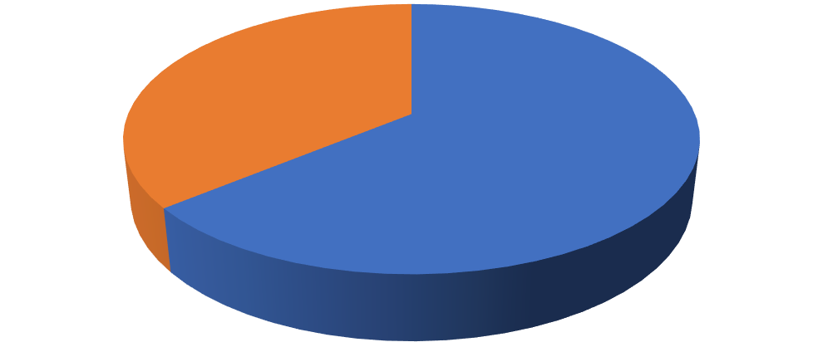

64

%

36

%

**Gender**

male

female

**Interpretation:**

Above Table and fig.4.2 shows the gender wise classification of respondents. It reveals that 64% are male and 36% are female.

**Q. 3 shows the qualification of respondents**.

|  |  |  |
| --- | --- | --- |
| **Qualification** | **Frequency** | **Percentage** |
| Plus two | 8 | 16% |
| Degree | 25 | 50% |
| PG | 8 | 16% |
| PG and above | 4 | 8% |
| Others | 5 | 10% |
| **Total** | **50** | **100%** |

(Source: primary data)

**Figure.4.3shows the percentage of qualification of respondents**

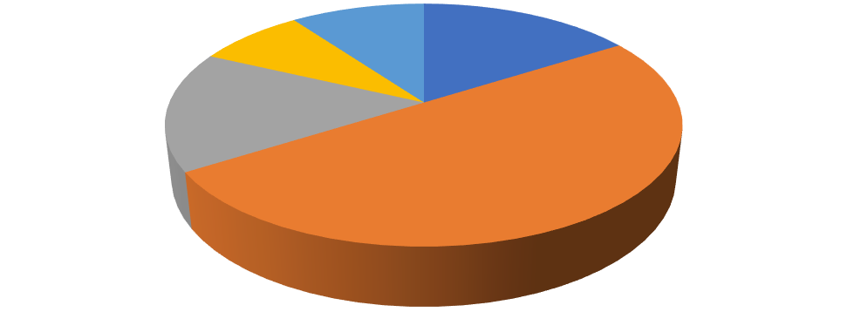

16

%

50

%

16

%

8

%

10

%

**QUALIFICATION**

PLUS TWO

DEGREE

PG

PG AND ABOVE

OTHERS

**Interpretation:**

Above data we can analyze 50%respondents are of degree students/completed their degree,16% of respondents are plus two students/ completed their plus two,16% of respondents doing their PG/ completed their PG,10% of the respondents have other qualifications and 8% qualified PG and above.

**Q. 4 How many of you own Nike products.**

|  |  |  |
| --- | --- | --- |
| **Response** | **Frequency** | **Percentage** |
| Yes | 50 | 100% |
| No | 0 | 0 |
| **Total** | **50** | **100%** |

(Source: primary data)

**Figure.4.4 shows the percentage having own product**.

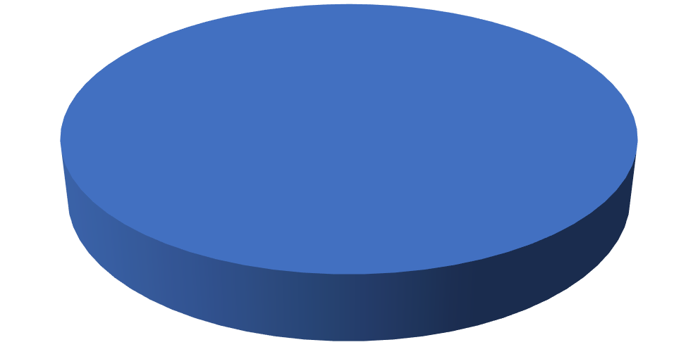

100

%

0

%

YES

NO

**Interpretation:**

Above table we can analyze that100% respondents own/use Nike products.

**Q.5 How’s the brand consciousness of respondents.**

|  |  |  |
| --- | --- | --- |
| **Response** | **Frequency** | **Percentage** |
| Yes | 45 | 90% |
| No | 05 | 10% |
| **Total** | **50** | **100%** |

(Source: Primary data)

**Figure.4.5 shows the brand consciousness of respondents.**

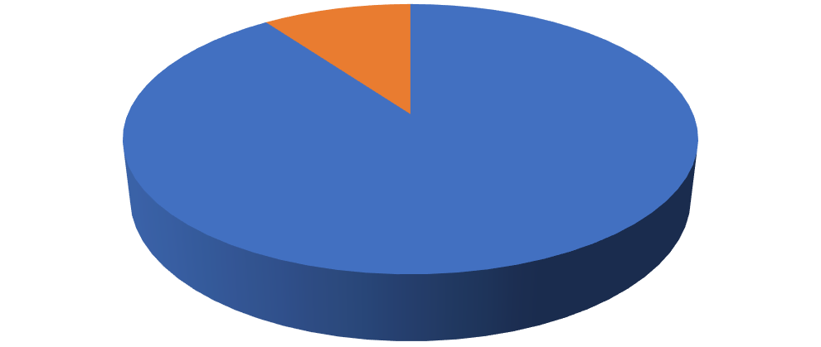

90

%

10

%

**BRAND CONSCIOUS**

YES

NO

**Interpretation:**

Above table.4.5, 90% respondents arebrand conscious and the remaining 10% are not brand conscious.

**Q.6 shows amount spent on Nike product.**

|  |  |  |
| --- | --- | --- |
| **Amount spent on Nike products** | **Frequency** | **Percentage** |
| Below 2000 | 15 | 30% |
| 2000-4000 | 28 | 56% |
| 4000-6000 | 6 | 12% |
| Above 6000 | 1 | 2% |
| **TOTAL** | **50** | **100%** |

(Source: primary data)

**Figure.4.6 shows amount spent on Nike product.**

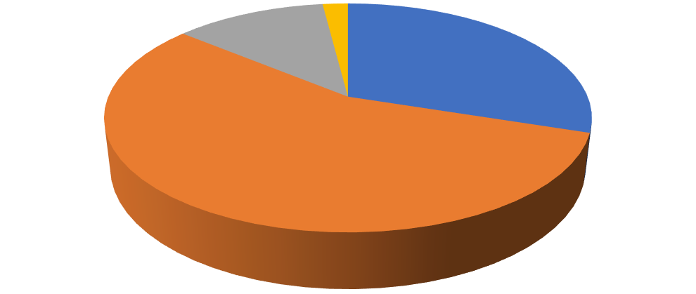

30

%

56

%

12

%

2

%

**AMOUNT SPENT ON NIKE PRODUCT**

BELOW 2000

2000-4000

4000-6000

ABOVE 6000

**Interpretation:**

The above table shows the amount spent on Nike products by the respondents. 56% of the respondents spent₹2000- ₹4000,30% of respondents spentbelow₹2000,12% of respondents spent amount in between ₹4000- ₹6000&2% of respondents spent above ₹6000.

**Q.7 how those who willing to purchase another brand with less price.**

|  |  |  |
| --- | --- | --- |
| **Purchase another brand with less price** | **Responses** | **Percentage** |
| Yes | 41 | 82% |
| No | 09 | 18% |
| **Total** | **50** | **100%** |

(source: primary data)

**Figure.4.7 shows the percentage of respondents who purchase another product with less price**.

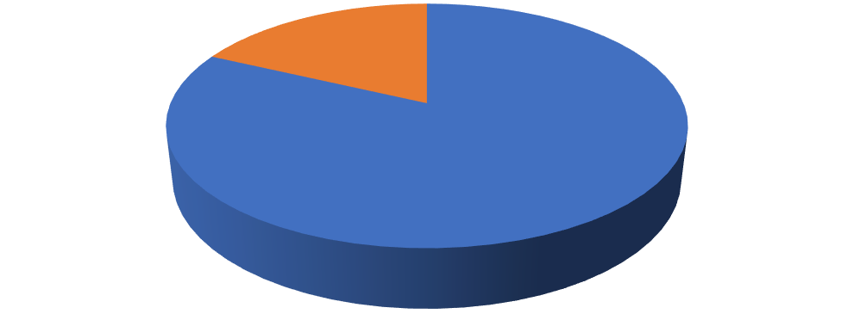

82

%

18

%

**PURCHASE ANOTHER PRODUCT WITH LESS**

**PRICE**

YES

NO

**Interpretation:**

From the above table 4.7, it clearly states that 82% are ready to purchase another product with less price and balance 18% are not readyto purchase another product with less price.

**Q.8 shows mode of purchase**

|  |  |  |
| --- | --- | --- |
| **Mode** | **Responses** | **Percentage** |
| Online | 30 | 60% |
| In store | 20 | 40% |
| **Total** | **50** | **100%** |

(Source: primary data)

**Figure. 4.8shows mode of purchase**

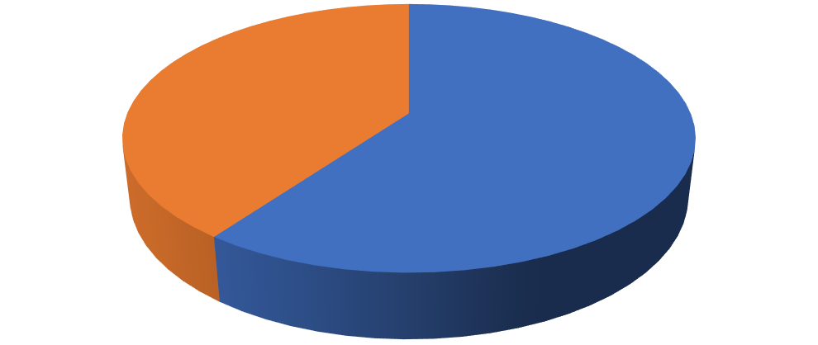

60

%

40

%

**BUYING PRODUCTS**

ONLINE

IN STORE

**Interpretation :**

Analyzing the above table4.8, 60% prefer online mode and 40% prefer in store mode.

**Q.9 shows respondents recommendation**.

|  |  |  |
| --- | --- | --- |
| **Particulars** | **Frequency** | **Percentage** |
| Yes | 35 | 70% |
| No | 5 | 10% |
| Sometimes | 10 | 20% |
| **Total** | **50** | **100%** |

(Source: Primary data)

**Figure.4.9 show respondents recommendation**

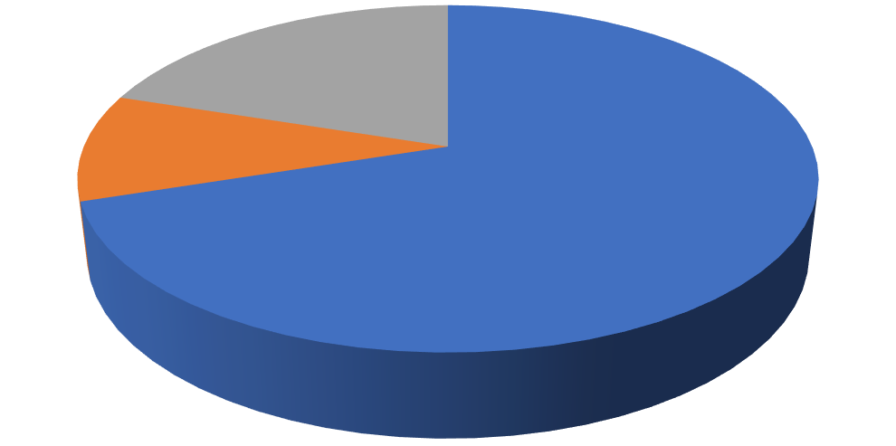

70

%

10

%

20

%

YES

NO

SOMETIMES

**Interpretation:**

Analyzing the above table.4.9, 70% are ready to recommend Nike products to others , 20% sometimes recommend it to others,10% not ready to recommend Nike product.

## FINDINGS

Secondary supports play an important role in the customers mind and create awareness among the customers.80% of the people are brand conscious while purchasing shoes.

When the respondents were asked about their brand preference, 50% said that they prefer Nike, 18% preferred Adidas, 10% preferred Puma, 12% went with Reebok and remaining 10% said that they would prefer other brands. This means that most of the people prefer buying Nike shoes.

According to survey, 8% prefer brand, 32% prefer quality, 6% vote for packaging, 26% prefer comfort, 22% prefer for personality & 6% for other as important element when buyer select their product.

According to respondent, 48% loyal to Nike, 16% loyal to Adidas, 14% loyal to Reebok, 12% loyal to Puma and 10% loyal to any other brand. According to survey, 16% switch to quality, 20% switch to price, and 26% switch to innovation, 18% switch to advertisement and 10% for other switch to buy the Footwear of another brand. The deciding factors for buying shoes for people are mainly comfort, quality and brand name, whereas, packaging and personality do not matte people.

34% responder vote for style, 20% responder for brand, 16% choose range, 12% responder choose both price and marketing and 6% prefer other as a successful element for the Nike footwear.

78% buyer bought any footwear influence by any ways of marketing or branding programs whereas 22% does not prefer any marketing or branding programs.

According to survey, 38% like the light weight, 30% like the comfort, 18% like the color and 14% like the durability as the most important features of Nike Footwear.

Product should be environment friendly during its manufacturing, during use & after their use. 86% customer consider environment friendliness in footwear.

Low range price Nike shoes are preferred by more than 40% buyer whereas high range is Prefer by only 6% responder.

When people were asked about Nike personalized or customized Footwear only 20% user were not aware about it 80% buyer know about customized footwear.

32% people buy Nike Footwear after 6 months, 52% (both) replaces their shoes after 9 month and above 1year and 16% people buy pair very rapidly.

88% persons are satisfied and rest are unsatisfied with Nike Footwear.

Acc. To responder Nike footwear is more durable than any another brands as 40% of the responder prefer Nike footwear over another.

Adidas is 2nd choice of people after Nike brand.

Price is very important factor in buying Nike footwear as 25 people out of 50 choose it as very important factor.

Durability is categorized as important factor as survey shows that 25 buyer choose it as important factor.

Brand play Very important role in buying footwear as 21 buyer voted it as very important feature.

Comfort & look are very important feature in footwear as responder also shows them as very important elements.

42% user buy both sportswear & casual shoes of Nike brand. Nike has made a reputed image in Sports footwear section; about 32% users buy Sports shoes of Nike Shoes.

Black color of Nike shoes is most famous color wear by the customer as 44% customer prefer black color over white (26%), grey (14%).

Nike has introduced customized or personalized footwear few years ago. Customized shoes are famous amongst the teenager as 72% of customer bought the personalized shoes.

Nike is well known brand for its durability, comfort, and style & price range. 44% customer were very well satisfied by the Nike Footwear.

Only 4% customer were not satisfied by Nike Footwear.

Price is the most important factor in deciding customer size in the market. Acc. To survey 80% people were satisfied with Nike footwear price range & rest were not satisfied.

## SUGESSTIONS

1. Customers want the company to take feedback regarding services and inform the about new Footwear design launched.
2. Nike should change warranty period from 5 years to 7 years.
3. Customers want more improvement in service.
4. “Nike” should give more advertisement through Television and should place more hoarding and bill boards, newspapers and should place more hoarding and billboards.
5. Nike must make clear the conditions applicable with warranty and guarantee plan.
6. Nike should charge less for after sale service.
7. Annual Maintenance Service should be given to reduce the loss of customers when a product gets faulty.
8. Network should be expanded to rural areas also.
9. Nike must improve their personnel selling and direct contacting to provide customers full knowledge about their products.

## CONCLUSION

The specific brand objective of Nike India would be to build up its brand reputation, image and equity. A brand is not simply a collection of products and benefits, but also a store house of value stemming from awareness, loyalty, and association of quality and brand personality. A brand is a name, term, sign, symbol or design or a combination of them intended to identify the goods or services of one seller or group of sellers and to differentiate from those of competitors the branding challenge is to develop a deep set of positive associations for the brand. Although these six meanings are noticeable in the Nike brand in the west and other parts of the world, they are yet to be cultivated in India. Nike has to ensure that their brand is built up on these pillars in India. The secondary brand objective of Nike India would be to ensure that they match the market share and sales volumes of its competitors. After all, a company is in business to make profits and stay ahead of its competitors. A company, product or brand may have a very good reputation and image, but if it is not profitable, it does serve its purpose. At the same time sales figures and data can be misleading. Hence market share has also to be paid attention to. Nike despite being one of the most popular brands in the world has not really caught on in India.

Yet, there is reason to believe that Bata’s Power and Liberty would be ahead of Nike in terms of popularity. We also notice that Nike is at par with Reebok. This again does not reflect too well on the brand, considering that Nike outsells Reebok everywhere else in the world.

Hence it is reasonable to state that Nike’s popularity level in India could do with a boost. The best way to achieve this would be some serious brand building. The image of the brand has to be improved and people must be made aware of its presence. Thus, the rationale behind choosing improvement of brand image and reputations the company’s primary objective is quite clear. Nike’s distinctive competency lies in the area of marketing, particularity in the area of consumer brand awareness and brand power. On the global scale this key distinctive competency towers over the competitors. As a result, Nike’s market share is number-one in the athletic footwear industry in most places around the world. Catch phrases like, "Just Do It”, and symbols like the Nike "Swoosh," couple with sports icons to serve as instant reminders of the Nike Empire. It is about time that this competency is leveraged on to India. Two key attributes of a distinctive competency are its inability to be easily replicated and the value or benefit it offers to consumers.

**Bibliography:-**

### BOOKS:-

* Rao V.S.P “Human Resource Management”, 3rd Edition, Excel Publication
* Charles W.L. Hill, Steven Mc. Shane, “Principle of management”
* Philip Kotler, “Marketing Management”
* Leon G. Schiff man, Joseph Wisenblit, S. Ramesh Kumar,

“Consumer Behavior”, Pearson Publication.

**WEBSITE:-**

* [https://m.nike.com](https://m.nike.com/)

## ANNEXURE

Q.1 Showing age wise classification of respondents.

1. 18-20
2. 21-24
3. 25-30

Q.2 Shows the gender wise classification of respondents.

(a) Male

(b) Female

Q.3 Shows the qualification of respondents

(a) Plus two

(b) Degree

(c) PG

(d) PG & above

(e) Others

Q. 4 How many of them own Nike products.

(a) Yes

(b) No

(c) None of these

Q.5 How’s the brand consciousness of respondents.

(a) Yes

(b) No

(c) None of these

Q.6 Shows amount spent on Nike product.

(a) Below 2000

(b) 2000-4000

(c) 4000-6000

(d) Above 6000

Q.7 weans those who willing to purchase another brand with less price.

(a) Yes

(b) No

Q.8 Shows mode of purchase.

(a) Online

(b) In-store

Q.9 Shows respondents recommendation.

(a) Yes

(b) No

(c) Sometimes

Q.10 Any suggestions ________________________________________ ______________________________________________________________________________________________________________________.

**Thank You**